The Best Practices Programme (BPP) for Local Authorities in Moldova

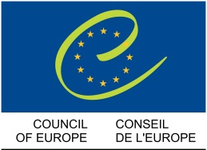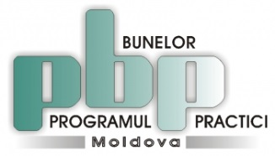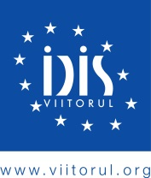
The Best Practices Programme for Local Authorities in Moldova is implemented by IDIS "Viitorul", with the financial support of the Council of Europe.

The aim of the programme
The programme aims to identify, appreciate, promote and disseminate the best practices among local authorities from Moldova, in order to improve the efficiency of local governance.

Implementation period:
2005 – currently

Donor:
Council of Europe

During 2005 - 2016, over 350 communities from Moldova shared their best practices that have been published in seven anthologies, and successful practices have become the subject of six documentaries distributed among local representatives from the country.

Sections to apply

INTEGRITY, GOOD GOVERNANCE AND TRANSPARENCY IN THE DECISION-MAKING PROCESS
Best practices from this section are referring to:
- Ensuring access to information
- Informational management in relation to citizens
- Ensuring transparency of local decisions and of the citizens’ involvement in the decision-making process
- Transparency and partnership between local government and civil society representatives

LOCAL ECONOMIC DEVELOPMENT AND INTERCOMMUNITY COOPERATION MODELS
Best practices presented by local authorities in this section refer to:
- Supporting local entrepreneurship
- Promoting gender equality in the management of local entrepreneurial activities
- Creating public - private partnerships: the basis of a sustainable local economy
- Sustainable public services through intercommunity cooperation
- Rural development and agro tourism

SUSTAINABLE SOLUTIONS FOR ENERGY EFFICIENT COMMUNITIES
Best practices from this section are referring to:
- The implementation of sustainable energy efficiency projects in public institutions
- Use of energy technologies in the management of public utility services
- Implementing energy conservation projects
- Improvement and rehabilitation of street lighting
- Informing the public about the impact of energy efficiency projects

EFFICIENT MANAGEMENT OF LOCAL PUBLIC SERVICES
Good practices presented by local authorities in this section refer to:
- The construction, rehabilitation, expansion and modernization of the supply and distribution of drinking water and sanitation
- Development of integrated waste management
- Efficient use of public assets
- Modernization of local roads infrastructure for citizens
- Provision of quality public services for everyone

Participating at the Best Practice Programme, local authorities representatives have the opportunity to inspire and to implement, in their communities, successful and performant models. In this way, the local government will become more efficient, and the quality of life of residents will improve noticeably.

A good local practice means success stories, partnerships and innovation and the Best Practice Programme comes in this sense, to ensure the sustainability of these initiatives by sharing knowledge, skills and experiences.

To see more information on the Best Practices Programme, please see the Informative Prospectus (available only in Romanian):

Prospectul Informativ "Împreună pentru performanțe în guvernarea locală 2014 - 2015"
Prospectul Informativ "Împreună pentru performanțe în guvernarea locală 2013 - 2014"
Prospectul Informativ "Împreună pentru performanţe în guvernarea locală 2012 - 2013"
Prospectul Informativ "Împreună pentru performanţe în guvernarea locală 2011 - 2012"

Open Days events in municipalities with the best practices
Material promoțional "Ziua Ușilor Deschise: Schimb de experiență și bune practici"

The Anthology of best practices
O antologie a bunelor practici ale autorităților publice locale din Republica Moldova, ediția 2016
O antologie a bunelor practici ale autorităților publice locale din Republica Moldova, ediția 2015
O antologie a bunelor practici ale autorităților publice locale din Republica Moldova, ediția 2014
O antologie a bunelor practici ale autorităților publice locale din Republica Moldova, 2013 edition
Ghidul Bunelor Practici ale Autorităţilor Publice Locale

The documentary “Together for performances in local government” (available only in Romanian)
„Împreună pentru performanțe în guvernarea locală” 2016
„Împreună pentru performanțe în guvernarea locală” 2015
„Împreună pentru performanțe în guvernarea locală” 2014
„Împreună pentru performanțe în guvernarea locală” 2013

Join the Best Practices community on Facebook:
https://www.facebook.com/Programul-Bunelor-Practici-ale-Autorit%C4%83%C5%A3ilor-Publice-Locale-din-Moldova-234732163398238/?ref=bookmarks

