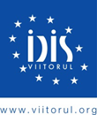
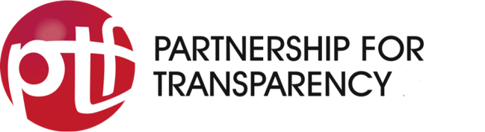
Request for Proposals:
Establishment of a Digital Platform within the project:
Increasing the Integrity of Public Procurement

Application Form
Please use the following form to submit your application.
Technical Proposal
- Company: experience and track record
  - Company
 | General information about the organization
1 | Name of the organization & name of the applicant
2 | IDNO (tax code) of the organization
3 | Legal address (street, no., postal code, locality)
4 | Postal address (address of the office where project team operates)
5 | Contact phone (for official communication)
6 | Web page
7 | Other internet presence (LinkedIn, Facebook; Twitter, etc.)
8 | E-mail (for official communication)
9 | Director (first name, last name)
10 | Office/mobile phone of the director
11 | Director's email
12 | Experience
Please attach company profile: description of the organization including portfolio and relevant prior projects to describe experience and track record
  - Project Team
No. | Name | Qualification  Short description of role, please attach all CVs | Daily Rate  All-inclusive rate including VAT
1
2
3
Please attach the CVs of all team members.
- Methodology
Deliverables
No. | Deliverable  see section 3 for details | Description of Approach  short description of how the deliverable will be produced and what it will look like | Team
No. | Deliverable  see section 3 for details |  | Lead  one team member responsible for this deliverable  (including working days allotted) | Support  all team members contributing to the production of this deliverable  (including working days allotted)
1 | Concept
2 | Beta Version
3 | Go Live
4 | Handover Workshop
5 | Operation
Financial Proposal
- Budget
No. | Deliverable | Team |  |  | Budget  (in USD, including VAT)
No. | Deliverable | Team member | Level of efforts  in working days | Daily Rate  all-inclusive rate incl. VAT | Budget  (in USD, including VAT)
1 | Concept | 1. Team member: XXX
1 | Concept | 2. Team member: XXX
1 | Concept | etc. (add lines as required)
2 | Beta Version | 1. Team member: XXX
2 | Beta Version | 2. Team member: XXX
3 | Go Live | 1. Team member: XXX
3 | Go Live | 2. Team member: XXX
4 | Handover Workshop | 1. Team member: XXX
4 | Handover Workshop | 2. Team member: XXX
5 | Operation | 1. Team member: XXX
5 | Operation | 2. Team member: XXX
Total budget

- Confirmation
By signing this form, the applicant confirms that:
- The data provided in this application is correct and authentic.
- The organization applying is not undergoing a seizure of accounts.
- The organization applying confirms the absence of debts to the National Public Budget.
- All necessary measures have been taken in the preparation of this project proposal to prevent any conflict of interest that may compromise the impartial and objective implementation of the monitoring project.

Place, Date Signature

This Application Form is prepared within the “Increasing Integrity in Public Procurement” project. The project is implemented by the Institute for Development and Social Initiatives (IDIS) Viitorul, in cooperation with the Partnership for Transparency (PTF) and it aims to support public procurement reforms in Moldova that will increase transparency and fairness in public procurement by empowering citizens to hold relevant institutions accountable.

